Мануальное тестирование. Задание 2

Руководствуясь лекцией по мануальному тестированию «MT2», нужно найти три найти дефекта и зафиксировать каждый в виде отчета (bug report).

Язык выполнения задания: английский

Можно выбрать ЛЮБУЮ ссылку из предложенных вариантов

Срок выполнения задания: 22 декабря 2024

Ссылки для тестирования:

Вариант 1

<https://www.saucedemo.com/>

Вариант 2

<https://svyatoslav.biz/testlab/wt/>

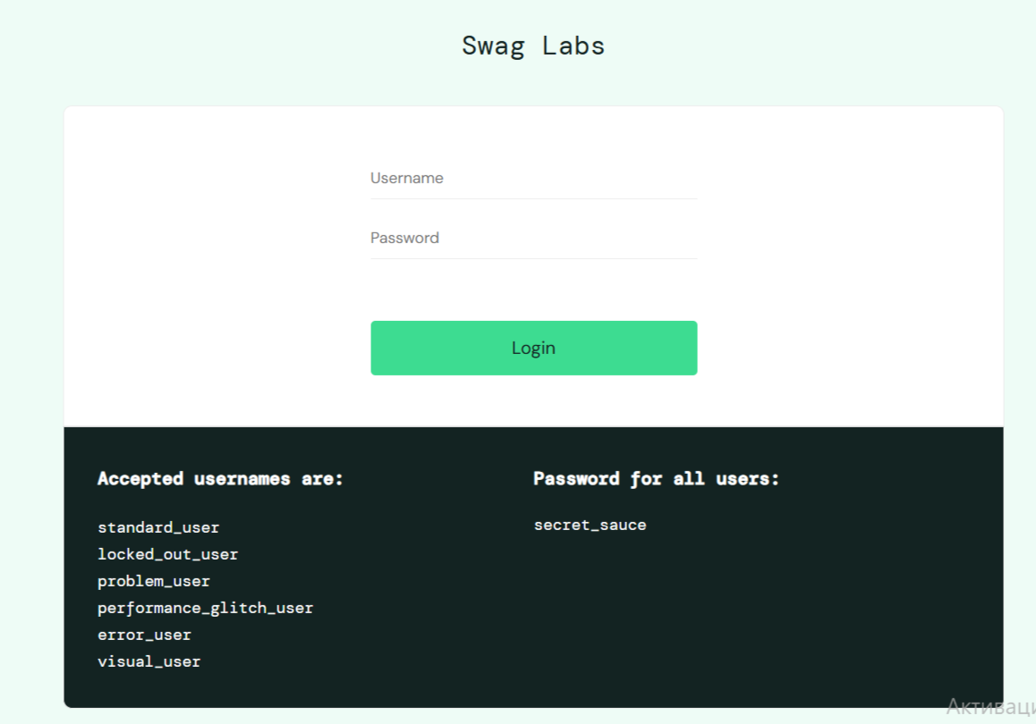

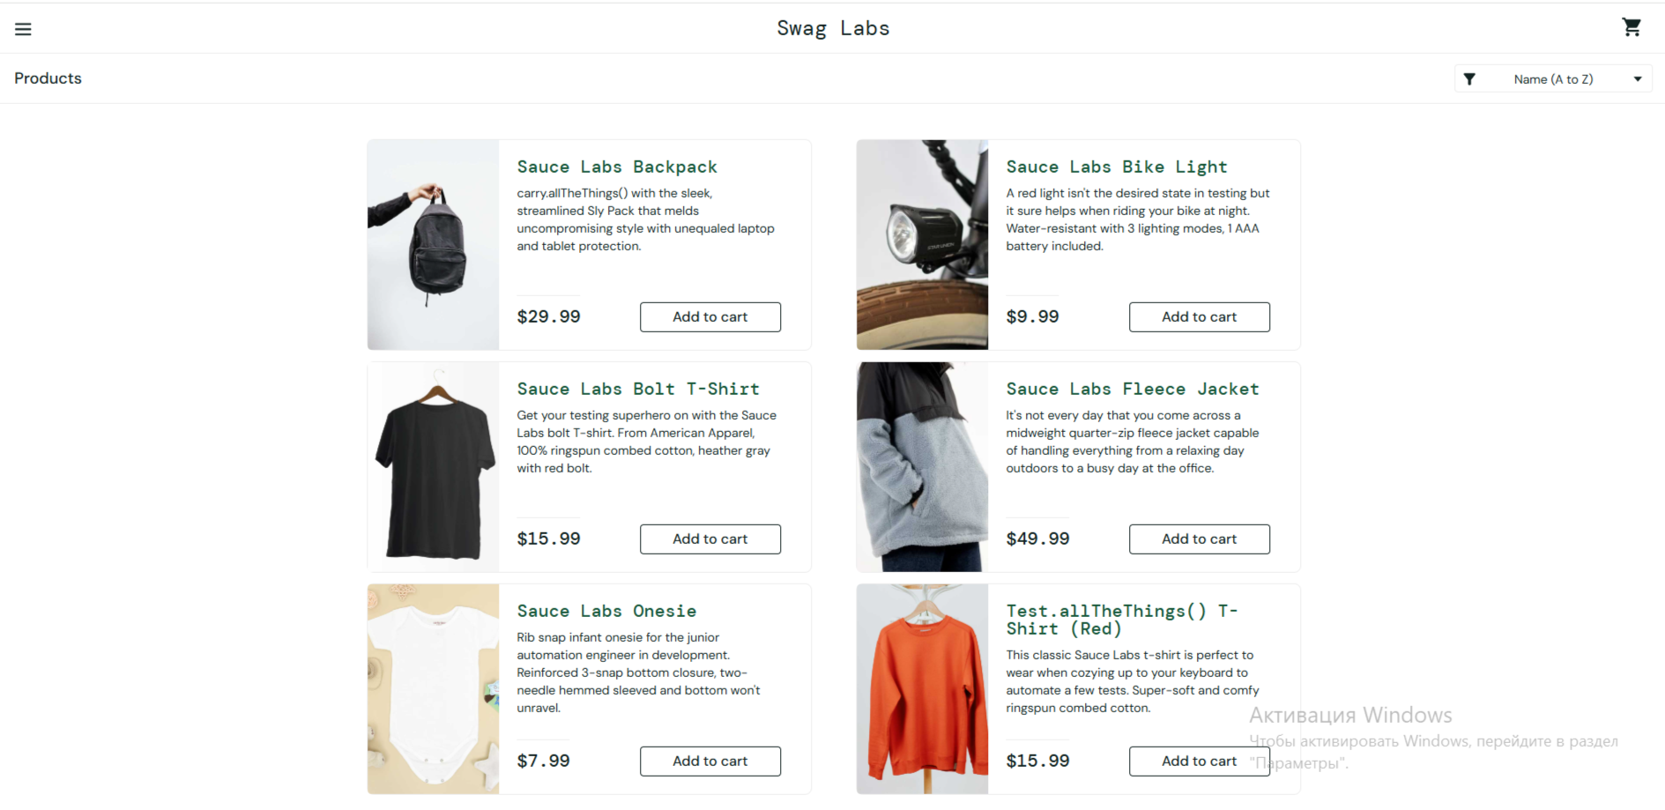

|  |  |  |  |  |  |  |  |  |  |  |
| --- | --- | --- | --- | --- | --- | --- | --- | --- | --- | --- |
| **ID** | **Summary** | **Detailed Description** | **Steps to Reproduce** | **Reproducibility** | **Severity** | **Priority** | **Symptom** | **Workaround** | **Comment** | **Attachments** |
| *001* | *Incorrect error message when entering invalid login data* | *When entering incorrect login data on the site, the error message does not appear.* | *1. Go to the login page. 2. Enter an incorrect username and password.  3. Click the "Login" button.  Actual Result: The error message does not appear. Expected Result: An error message is displayed.* | *Always* | *High* | *High* | *Incorrect operation* | *None* | *Need to check error messages on all pages.* | *Screenshots, if available.* |
| *002* | *Incorrect operation of the "Add to Cart" button* | *When clicking the "Add to Cart" button for some products, the item is not added to the cart.* | *1. Go to the main page of the site. 2. Click the "Add to Cart" button for the "Sauce Labs Backpack" product.  3. Check the cart contents.  Actual Result: The item is not added to the cart. Expected Result: The item is added to the cart.* | *Always* | *High* | *High* | *Incorrect operation* | *None* | *Need to check the button's operation for all products.* | *Screenshots, if available.* |
| *003* | *Error when filtering products by price* | *When filtering products by price, the site gives an error and does not display results.* | *1. Go to the products page.  2. Select the "Price (low to high)" filter.  3. Check the display of results.  Actual Result: The site gives an error, and results are not displayed.  Expected Result: Products are displayed in ascending price order.* | *Always* | *High* | *High* | *Performance issue* | *None* | *Need to check the operation of all filters.* | *Screenshots, if available.* |